

**Clear Shield Concepts, LLC**

**Presented by:**

**Aaron Frazier**

**aaron@clearshieldconcepts.com**

Funding Consultant

800-839-3290

c/o J. Roberts

Greenbriar-consulting.com

**Strategic Business Plan**

**February 14, 2020**

**CONFIDENTIAL DATA**

All Financials, Plans, and Business Projections contained herein are the proprietary property of Clear Shield Concepts, LLC and may not be copied, shared or disclosed to any third party without written permission.

ABSTRACT



**ABSTRACT**

**This Strategic Business Plan for Clear Shield Concepts, LLC, hereinafter ‘CSC’ or ‘The Company’, has been prepared based upon a due diligent analysis of regional and national industry space for Coatings and Resins – specifically Auto Body Coatings. In addition, The Company’s Business Model is based upon a Standard, 5-Year model.**

**Definition of Business Plan Approach:**

**This Business Plan is summary in nature because of the dependence on planned Equity Funding rather than public-intent venture capital. It is for this reason that the final business formation is an ‘LLC’ Corp.**

**Financial Model and Statements:**

**The Planning Horizon for the business plan is Five (5) Years and, as such, reflects Goals and Objectives on an Annual basis only. Detailed, Monthly Income Statements, Balance Sheets, and Cash Flow Analysis are available upon request.**

**Business Plan Compliance:**

**This Strategic Business Plan fits the format and content requirements for its business model and is suitable for external review by all Capital Investors, banks and an audit of intended business operations.**



TABLE OF CONTENTS



Cover Page .....................................1

Abstract..........................................2

Table of Contents...........................3

EXECUTIVE SUMMARY...................4

STRATEGIC PLAN………………………5

MISSION & VISION...………………….6

INDUSTRY FOCUS…….……...……….7

OPPORTUNITY….…….………………….8

PRODUCTS & SERVICES….…………9

COMPETITION….………………………13

OPERATING PLAN...………………….16

MARKETING PLAN...………………….21

FEASIBILITY STUDY…………………24

MANAGEMENT TEAM .………………26

FINANCIAL SUMMARY....……………27

FINANCIAL STATEMENTS…....….….28

EXECUTIVE SUMMARY



**INTRODUCTION:**

**Many Business Plans are produced in the U.S. annually. Rarely does a business opportunity emerge that has the potential to be a national force in the Auto Coatings Industry – specifically in Clear Coatings - within simply a few years. That is precisely the potential of the business that you are about to learn about. It is the result of years of intensive research and exploration by the Founder and the resulting business model and its potential are significant by any standard. The emerging business we are speaking of here is named Clear Shield Concepts, LLC.**

**BUSINESS CONCEPT:**

Our business is all about Paint Protection Film. We increase a dealership’s per vehicle profit on every vehicle sold. Paint Protection Film is one of the highest grossing aftermarket products. Add it to the inventory of new and used vehicles. Shielding from scratches, scuffs and chips. Sometimes called "wear and tear protection package," require no more than $10-$15 in film materials, take less than 10 minutes to complete and offer a markup to the dealership of $195 to $1,495. We also provide compliance addendums saving the dealership time and boosting the penetration of the 3M preload program.

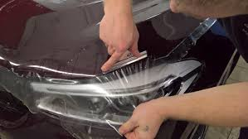

STRATEGIC PLAN



**PRIMARY GOALS:**

* **Obtain first round funding of $500,000 in support of the first 12 months of expanded operations.**
* **Emphasize both rapid marketing campaigns and expansion of our initial office space.**
* **Hire a General Manager and Sales Executives.**
* **Achieve Objective Profitability in Year 1.**
* **Experience Annual Revenue Growth at over 30+% throughout the first five years.**

## KEYS TO SUCCESS:

* **Rapid acquisition and promotion of Dealership Clients for our services, per our plan.**
* **Quickly establish us as a major player in Auto Dealerships in new cities.**
* **Utilize high-performance marketing technology – i.e. Webinars and Videos – and “Sunday Barbeque Open House” events and other marketing techniques.**
* **Expand rapidly from a CA-based operation into other major target markets, like Atlanta, Miami, Las Vegas and Los Angeles by Year 3.**



MISSION & VISION



**MISSION STATEMENT:**

**Our Mission at CSC is to be the new spirit and champion of all Client Dealerships that we target. We will use the power in dedicated, well-paid Commissioned Sales Reps to accomplish this goal**

**VISION FOR THE FIRST 5 YEARS:**

**Our company's purpose for the first 5 years is to provide Clear Coat services, with initial growth in the Southern California area and statewide. We will then begin to expand nationally while beginning to establish long-term joint ventures with other potential Automotive Aftermarket firms.**

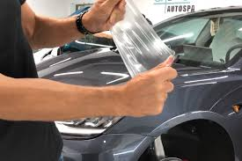

INDUSTRY FOCUS

**Auto Paint Protection Film: Product Value Summary:**

**The paint protection film is critical for automobiles. Without a paint protection film, the car will lose its elegant and shiny appearance and resale value. Sunlight, scratches, harsh cleaners, gasoline, and tree sap can be very damaging to the car’s appearance and can take away its glossy finish. Robust product demand for paint protection in automobiles, electronic gadgets, boats, ships, and aircraft has boosted the paint protection film market growth. Furthermore, market players are focusing on technological innovation to offer sustainable products with minimal environmental impact. This factor is projected to propel product demand. The automobile application segment is expected to register a considerable contribution to the growth of the market.**

**Product variation in terms of performance, quality, and efficiency to resist abrasions, scratches, and stains is foreseen to be the major factor for defining the demand for Paint Protection Film. Similarly, the introduction of modern technologies to manufacture long-lasting and high-quality paint protection film with improved resistance against adverse atmospheric conditions is expected to drive the market growth. Ongoing technological advancements, including colour variations, thickness variations, and superior adhesiveness in films are foreseen to attract customer attention. Advanced ceramic coating technologies are likely to be used as an alternative to paint protection film, on account of their long-lasting nature and superior performance against scratches and abrasions, thus impacting the market growth.**

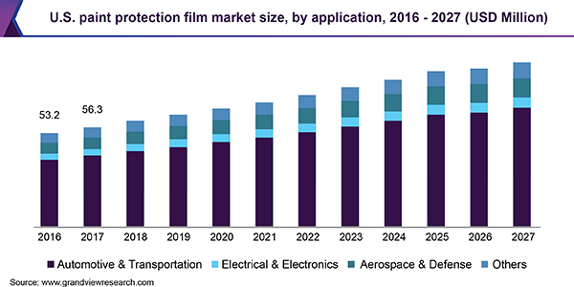

INDUSTRY FOCUS [Cont’d]

**Global Paint Protection Film Market Share Summary:**

**Paint Protection Film Market** **size is likely to portray a significant growth in the coming years due to developments in the automotive industry. Paint protection film is a thermoplastic material which when applied on painted surfaces heals automatically. The product is extensively used in automotive industry to protect the parts which are more susceptible to abrasion or damage. Paint protection film is used in various parts of the vehicle like bonnet, door panel, rear bumper, front bumper, side skirt, side panel, etc. The product protects the vehicle from stain caused by surface from dirt, oil, tar, bugs, etc. It also enables to maintain the vehicle surface finish flawless for a long time. Rising demand for lightweight vehicles and electrical cars would in turn propel the paint protection film market in the coming years.**

**Progress in the electronic market will augment the growth in the paint protection film market size due to its usage in various electronic equipment like cell phones, LED screens, household appliances, etc. The consumer electronics market size was around USD 330 billion in 2018 and is likely to grow at a growth rate of more than 7%. Out of this, Asia Pacific alone accounted for more than 50% of the market. Hence, rising trend in the consumer electronics industry would make Asia Pacific a significant market in the coming years.**

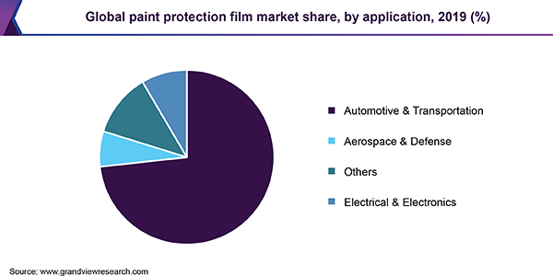

TARGET MARKET OPPORTUNITIES

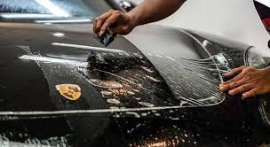

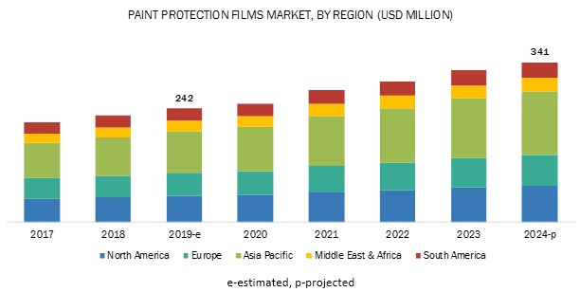

TARGET MARKET OPPORTUNITIES

**CONTINUING TARGET MARKET: Paint Protection Film**

## Installed on new and used vehicles, 3M Paint Protection Film, also known as “clear bra,” is a nearly invisible film that is applied to the painted surfaces of your car (hood, fender, bumper, mirrors, etc.) to protect them from road debris such as rocks, bugs, salt, etc. Made of a 6 mil (.006”) thick clear urethane plastic (8 mil when you count the adhesive), 3M Paint Protection Film was initially designed to protect helicopter blades from debris during the Vietnam War. Since then, it has been used by various auto manufacturers and NASCAR teams to protect painted surfaces from rock chips. Maintain the appearance of your vehicle and enhance its trade-in value by protecting its paint with 3M Paint Protection Film.

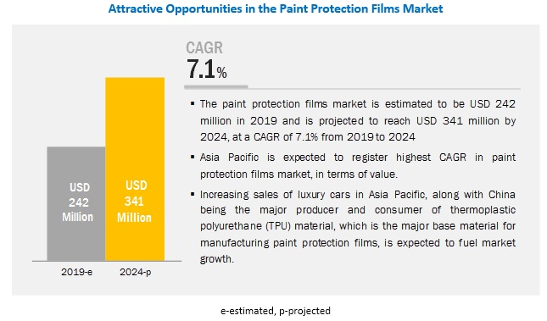

TARGET SUBMARKET: KEY DEVELOPMENTS

## ****Key Segmentation and Trends in the Market:****

**By finish, paint protection film market is segmented into matte finish and gloss finish. Gloss finish segment is likely to have a significant market share owing to its easy maintenance than matte finish. Although both matte and gloss finish have self-healing feature, but maintenance process of gloss finish for an individual would be much easier than the other. All matte finished surfaces are not same and hence, it may not match the amount of sheen and texture of the matte paint of the vehicle. Matte shaded surfaces are prone to damage and more expensive than the glossy ones.**

**Based on application, the paint protection film market size is further categorized into automotive & transportation, electronics, aerospace & defense, marine, and others which include energy, etc. Aerospace & defense segment is likely to grow at a rising CAGR in the coming years due to extensive usage of the product to protect the aircraft surfaces. It helps to protect from dirt, high impact abrasion and scratches on glass made parts. The product is applied for both interiors and exteriors of the aircrafts. The active global commercial fleet was estimated to be around 26,000 aircrafts in 2018 which is likely to increase to about 37,000 in the next ten years. This will in turn increase the market demand.**

 

PRODUCTS AND SERVICES

**Product & Service Offerings:**

**Our services here at Clear Shield Concepts include primarily Paint Protection Film Application Services. We are not primary Product Sources, meaning that we do not sell Clear Coating Film as wholesale or retail products. Instead, we market an application of the Paint Protection Film to new cars in the partner dealership. This enables the Dealership to add up to $110,000 per month in Sales Revenue.**

**3M Scotchgard™ Pro Series Clear represents the latest technology in paint protection film. The unique technology that separates this product from its competitors is a true testimony to 3M’s innovation. Industry-leading clarity (less orange peel) and self-healing and stain-resistant characteristics, Scotchgard Pro Series is designed to give you years of protection and performance without ongoing maintenance. Unlike your car’s paint, when 3M Pro Series is scratched, the scratches virtually disappear, keeping your film looking newer longer. It is warrantied for labor and material by 3M Company for ten (10) years. 3M offers an optional warranty that if the film fails and the paint is compromised 3M will pay up to $3,500.00 to repair the damage. Virtually nothing can protect your vehicle better from scratches, stains, and chips than 3M Paint Protection Film Pro Series. It’s truly the ultimate protection for paint.**

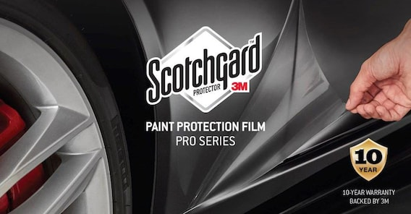

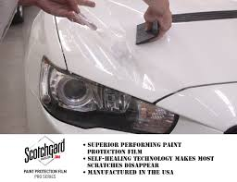

PRODUCTS AND SERVICES

**How We Provide Services:**

**We give a dealer car buyers confidence that their investment will be protected from scratches, chips, light dents and more with 3M Paint Protection Film. Have it installed right at the dealership before they ever drive it off the lot. Scotchgard Paint Protection Film is our best film to install with the highest quality and best warranty to ensure customer satisfaction. Clear Shield Concepts provides dealerships with the tools they need to successfully increase their monthly revenue $30K-$110K.**

**We install each vehicle within 10 minutes. charging $35-$60 per install. Our cost of each install is roughly $16-$25. We at present have 30 dealerships we service, adding several a monthly with our current staff of 2 sales reps. Our proven system and business plan generate anywhere from $3,800-$28,000 in monthly gross sale for our company, of which there are $2,500-$28,000 being invoiced in net sales per store. In regard to each dealership, they benefit by $30K-$110K in added gross revenue per store with our preload program. There are close to 60,000 new car automotive dealerships in the U.S., moving anywhere from 100 to 1,000 vehicles a month.**

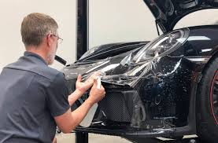 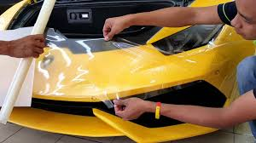

COMPETITION



**COMPETITIVE ANALYSIS:**

**Technically, our competition in the Paint Protection Film Market is everyone else in this market. However, because we utilize 3M Products – which are universally accepted as the best in the Industry - we believe our ‘lean and mean’ operating strategy and our aggressive approach to both acquisition and enhancement of new Dealership Clients, coupled with highly professional Sales Agents and Management puts us in a class by ourselves.**

**The majority of our services are simply not to be surpassed by any other products and services in this industry.**

**Therefore, we will quickly outdistance our competition. For these reasons, our management is not concerned as regards competition.**



OPERATING PLAN

**OPERATING STRAGEGY:**

Our Operating Strategy is to acquire new Dealership Clients through direct Sales. As detailed in the Marketing Section below, we believe that we can easily eclipse the Goals in this Business Plan.

**OPERATING PLAN:**

**As stated, we intend to hire train and set out a highly talented, experienced and motivated Sales Force. These will be commissioned Salespeople, ideally with experience in Automotive Aftermarket sales and an understanding of how New Car Dealerships operate. We plan to closely monitor all their activities and basically establish a ‘Pay for Performance’ mindset. As they prove themselves, we plan to offer support elements – Phone, Tablet, Calling Card, Benefits and related elements. Also, we will have a permanent hire staff for Website and Database management.**

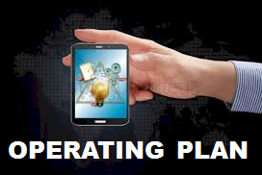

OPERATING PLAN [Cont’d]

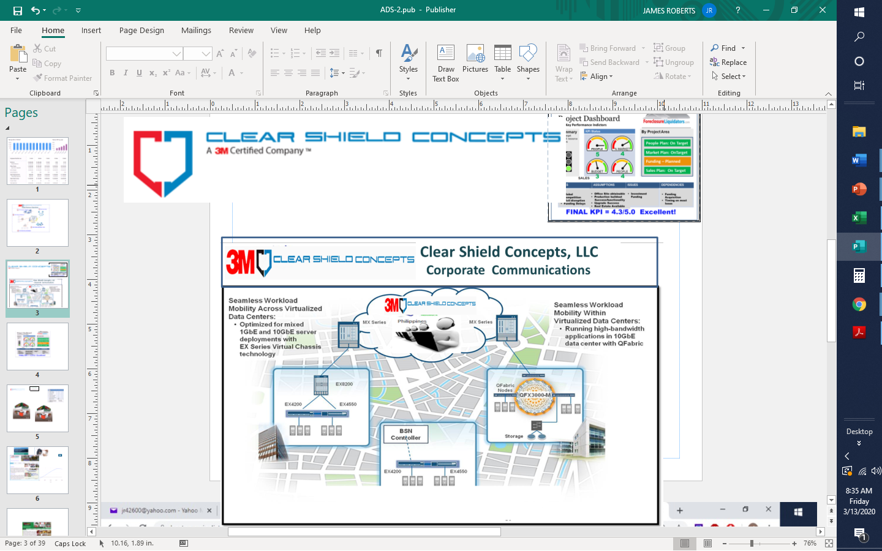

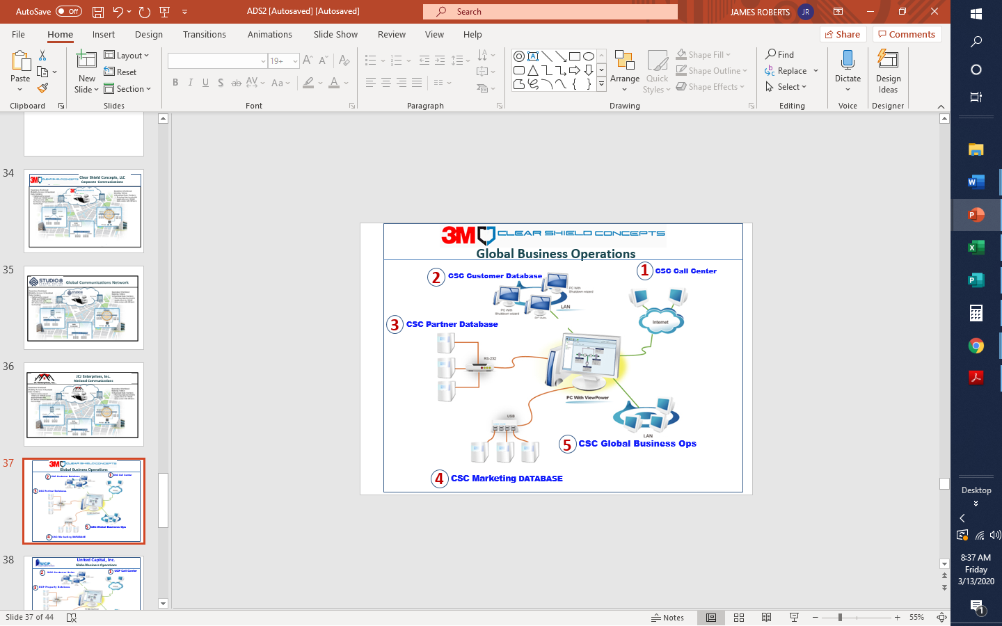

OPERATING PLAN [Cont’d]

**OPERATING FRAMEWORK:**

**In any organization, it is necessary for everyone to congruent as regards how the operating environment will function and flow. There need to be established Processes that will be followed as well as written, standard Policy & Procedures that are to be utilized in every situation requiring consistency and control. These need to be tied to the authorizing elements of the Strategic Plan so that resources are dedicated by priority, by time period, by department. The following graphic reflects the process that the Company will follow:**.

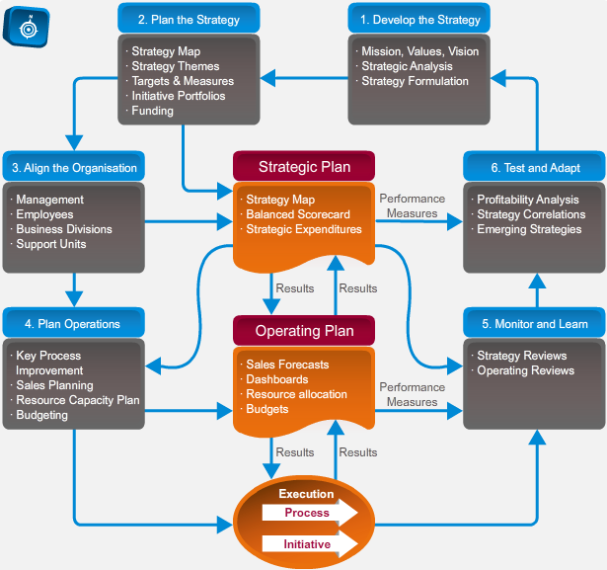

MARKETING PLAN



**MARKETING STRATEGY:**

**Clients are Car Dealerships in and around San Clemente, CA Our Strategy is one of both Direct and Indirect outreach. Direct Marketing: We plan to email a full color graphic ad for New Car Dealerships in the city and surrounding Counties. This is our primary Direct Marketing technique.**

**Indirect Marketing: We plan to utilize Banner Ads, as well as Google Adwords and Pay-Per-Click Ads to drive calls to our call center, which will then be linked directly to salespeople. We will also use high-performance marketing technology – i.e. Webinars and Videos – and “Sunday Barbeque Open House” events and “First Month Free” promotions in regard to the Auto Dealership Market.**

**Below is a screenshot of the CSC Website**

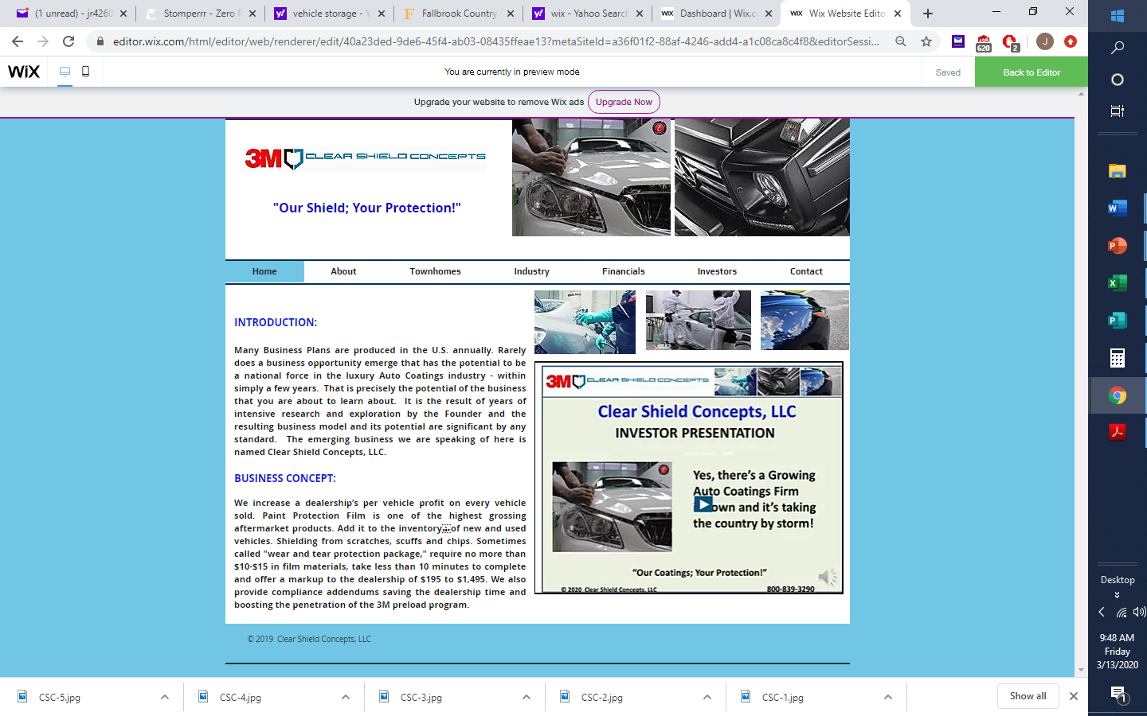

MARKETING PLAN [Cont’d]

**Our Long-term Marketing strategy is to utilize commissioned Sales Reps. The average sales rep can acquire approximately 1-3 dealership accounts per month of normal sales activity. With our perfected training and duplication model, we can plug and play a team in place within a single week to service the needs of 10 dealerships, anywhere in the four corners of the U.S. We currently have a strong presence in So. California, with newfound focus in upstate NY, and Florida.**

**We believe that it is simply a matter of working through the numbers to expand to 10 regional sales reps across the U.S. adding 200 stores within the first 12 months of our national expansion push. On the low end our projections have us with net sales of $4.6-$7M within that first year.**

**Below is a screenshot of the CSC Promo Video:**

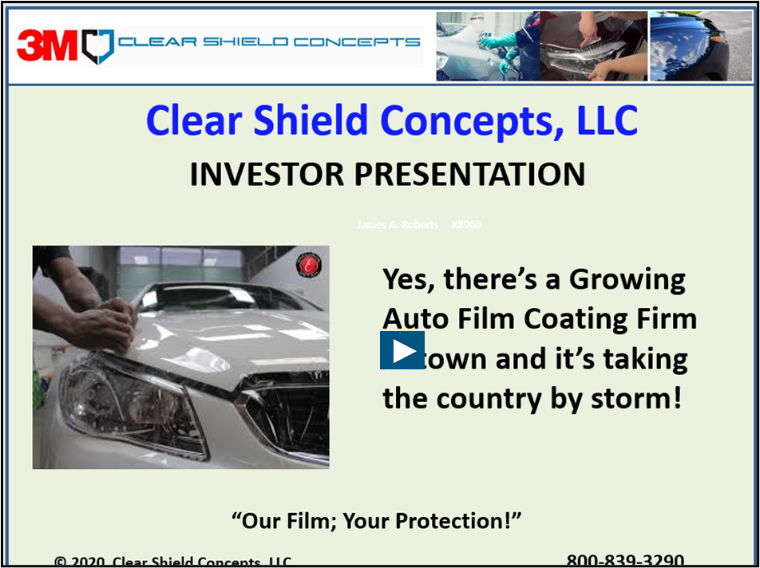

SALES INFORMATION:

**The entire world of Sales has seen a revolution in recent years, especially in regard to the manner in which Sales Activity, History and Closed Sales are recorded and managed. This process, now referred to as CRM – Customer Resource Management – can be expensive to manage but it need not be. There are many inexpensive CRM resources and database software that allow the prudent business owner to record and analyze both Sales-related Activity and closed business. The Company intends to utilize CRM inexpensively but effectively. We want to know what motivated a Renter to lease with us, and what and when a given Customer is likely to lease next.**

**Below is presented the type of Sales Information Dashboard that this software will provide.**

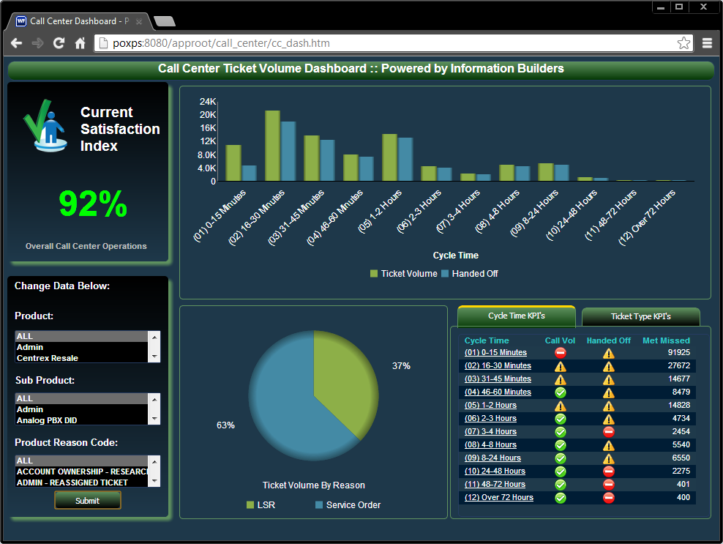

FEASIBILITY STUDY



**A Feasibility Study is appropriate when a Startup is offering a totally new product/service or is entering a market with apparently no or little competition and it is appropriate to analyze its probability of success in the marketplace, so that Investors may fairly and intelligently evaluate it. A Feasibility Study has two phases: 1) an SWOT Analysis – evaluating its Strengths, Weaknesses, Opportunities, and Threats; and 2) an assessment and presentation of its KPIs – Key Performance Indicators.**

**The SWOT Elements and Sub-Categories are presented in the below graphic. The KPIs are presented overleaf. Final KPI reflects an aggregate Startup assessment of ‘EXCELLENT’!**

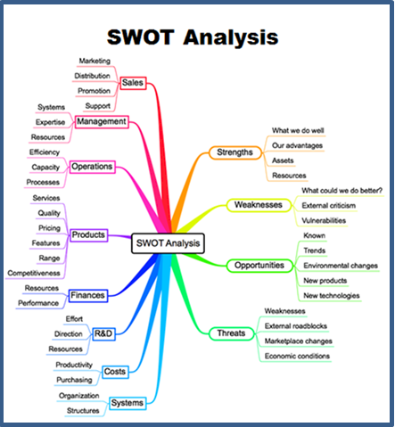

FEASIBILITY STUDY [Cont’d]

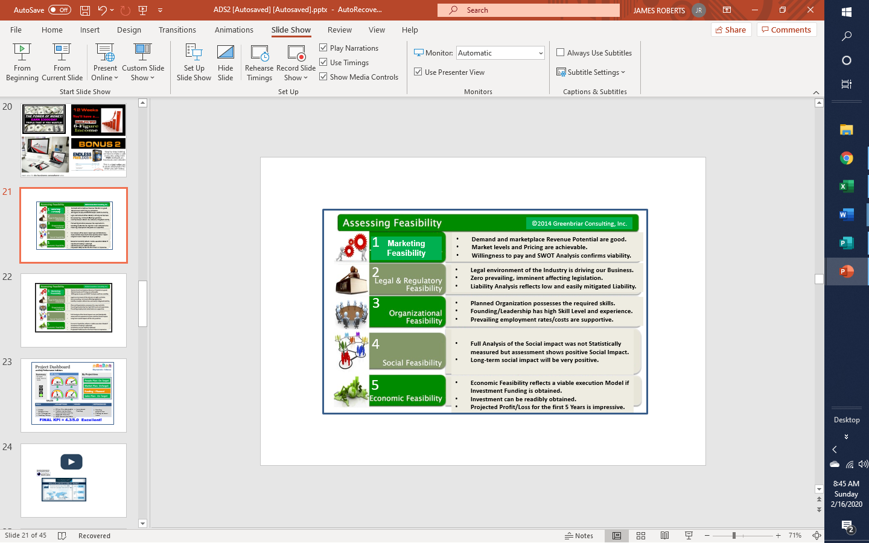

FEASIBILITY STUDY [Cont’d]

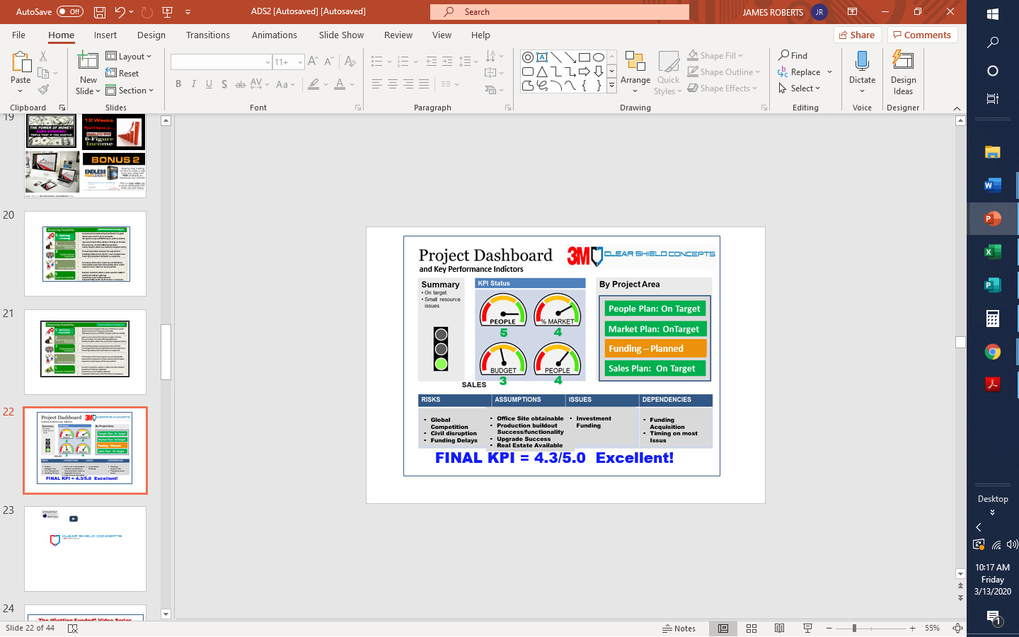

MANAGEMENT



FINANCIAL SUMMARY



**FUNDING REQUIREMENT:**

**The company is currently raising an initial round of $500,000 Investor Funding for an ownership stake in the firm, acquiring in the 2nd Quarter 2020. The earnings-based valuation of the company [@12%] in Fiscal Year 5 will be approximately $26.6 Million.**

**While the Company is open to multiple Investment Scenarios, the preferred target Investor is an Angel Investor with experience in Automotive Aftermarket.**

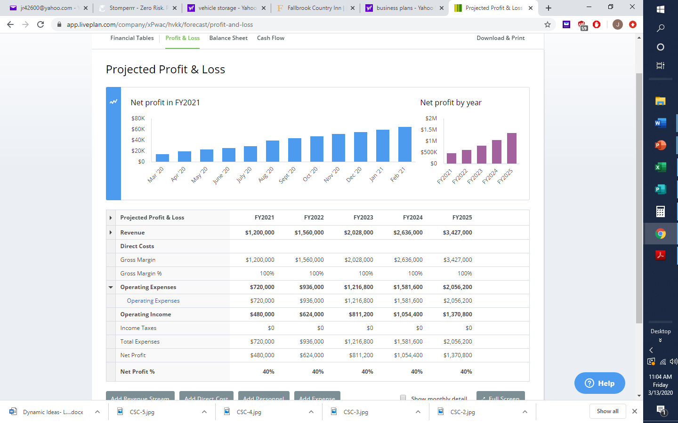

## Financial Statements

### Projected Profit and Loss

|  |  |  |  |  |  |
| --- | --- | --- | --- | --- | --- |
|  | FY2021 | FY2022 | FY2023 | FY2024 | FY2025 |
| Revenue | $1,200,000 | $1,560,000 | $2,028,000 | $2,636,000 | $3,427,000 |
|  |  |  |  |  |  |
| Direct Costs |  |  |  |  |  |
|  |  |  |  |  |  |
| Gross Margin | $1,200,000 | $1,560,000 | $2,028,000 | $2,636,000 | $3,427,000 |
| Gross Margin % | 100% | 100% | 100% | 100% | 100% |
| Operating Expenses |  |  |  |  |  |
| Operating Expenses | $720,000 | $936,000 | $1,216,800 | $1,581,600 | $2,056,200 |
| Total Operating Expenses | $720,000 | $936,000 | $1,216,800 | $1,581,600 | $2,056,200 |
|  |  |  |  |  |  |
| Operating Income | $480,000 | $624,000 | $811,200 | $1,054,400 | $1,370,800 |
|  |  |  |  |  |  |
| Interest Incurred |  |  |  |  |  |
| Depreciation and Amortization |  |  |  |  |  |
| Gain or Loss from Sale of Assets |  |  |  |  |  |
| Income Taxes | $0 | $0 | $0 | $0 | $0 |
| Total Expenses | $720,000 | $936,000 | $1,216,800 | $1,581,600 | $2,056,200 |
| Net Profit | $480,000 | $624,000 | $811,200 | $1,054,400 | $1,370,800 |
| Net Profit / Sales | 40% | 40% | 40% | 40% | 40% |

### Projected Balance Sheet

|  |  |  |  |  |  |
| --- | --- | --- | --- | --- | --- |
|  | FY2021 | FY2022 | FY2023 | FY2024 | FY2025 |
| Cash | $980,000 | $1,604,000 | $2,415,200 | $3,469,600 | $4,840,400 |
| Accounts Receivable | $0 | $0 | $0 | $0 | $0 |
| Inventory |  |  |  |  |  |
| Other Current Assets |  |  |  |  |  |
| Total Current Assets | $980,000 | $1,604,000 | $2,415,200 | $3,469,600 | $4,840,400 |
|  |  |  |  |  |  |
| Long-Term Assets |  |  |  |  |  |
| Accumulated Depreciation |  |  |  |  |  |
| Total Long-Term Assets |  |  |  |  |  |
|  |  |  |  |  |  |
| Total Assets | $980,000 | $1,604,000 | $2,415,200 | $3,469,600 | $4,840,400 |
|  |  |  |  |  |  |
| Accounts Payable | $0 | $0 | $0 | $0 | $0 |
| Income Taxes Payable | $0 | $0 | $0 | $0 | $0 |
| Sales Taxes Payable | $0 | $0 | $0 | $0 | $0 |
| Short-Term Debt |  |  |  |  |  |
| Prepaid Revenue |  |  |  |  |  |
| Total Current Liabilities | $0 | $0 | $0 | $0 | $0 |
| Long-Term Debt |  |  |  |  |  |
| Long-Term Liabilities |  |  |  |  |  |
|  |  |  |  |  |  |
| Total Liabilities | $0 | $0 | $0 | $0 | $0 |
|  |  |  |  |  |  |
| Paid-In Capital | $500,000 | $500,000 | $500,000 | $500,000 | $500,000 |
| Retained Earnings |  | $480,000 | $1,104,000 | $1,915,200 | $2,969,600 |

|  |  |  |  |  |  |
| --- | --- | --- | --- | --- | --- |
| Earnings | $480,000 | $624,000 | $811,200 | $1,054,400 | $1,370,800 |
| Total Owner's Equity | $980,000 | $1,604,000 | $2,415,200 | $3,469,600 | $4,840,400 |
|  |  |  |  |  |  |
| Total Liabilities & Equity | $980,000 | $1,604,000 | $2,415,200 | $3,469,600 | $4,840,400 |

### Projected Cash Flow Statement

|  |  |  |  |  |  |
| --- | --- | --- | --- | --- | --- |
|  | FY2021 | FY2022 | FY2023 | FY2024 | FY2025 |
| Net Cash Flow from Operations |  |  |  |  |  |
| Net Profit | $480,000 | $624,000 | $811,200 | $1,054,400 | $1,370,800 |
| Depreciation & Amortization |  |  |  |  |  |
| Change in Accounts Receivable | $0 | $0 | $0 | $0 | $0 |
| Change in Inventory |  |  |  |  |  |
| Change in Accounts Payable | $0 | $0 | $0 | $0 | $0 |
| Change in Income Tax Payable | $0 | $0 | $0 | $0 | $0 |
| Change in Sales Tax Payable | $0 | $0 | $0 | $0 | $0 |
| Change in Prepaid Revenue |  |  |  |  |  |
| Net Cash Flow from Operations | $480,000 | $624,000 | $811,200 | $1,054,400 | $1,370,800 |
| Investing & Financing |  |  |  |  |  |
| Assets Purchased or Sold |  |  |  |  |  |
| Net Cash from Investing |  |  |  |  |  |
| Investments Received | $500,000 |  |  |  |  |
|  |  |  |  |  |  |

|  |  |  |  |  |  |
| --- | --- | --- | --- | --- | --- |
| Net Cash from Financing | $500,000 |  |  |  |  |
| Cash at Beginning of Period | $0 | $980,000 | $1,604,000 | $2,415,200 | $3,469,600 |
| Net Change in Cash | $980,000 | $624,000 | $811,200 | $1,054,400 | $1,370,800 |
| Cash at End of Period | $980,000 | $1,604,000 | $2,415,200 | $3,469,600 | $4,840,400 |